**Seasons With Average Productions**

As production of crops depends on different seasons, so let’s plot the graphs to visualize the average production based on different seasons. You can find the average productions briefing in this video.

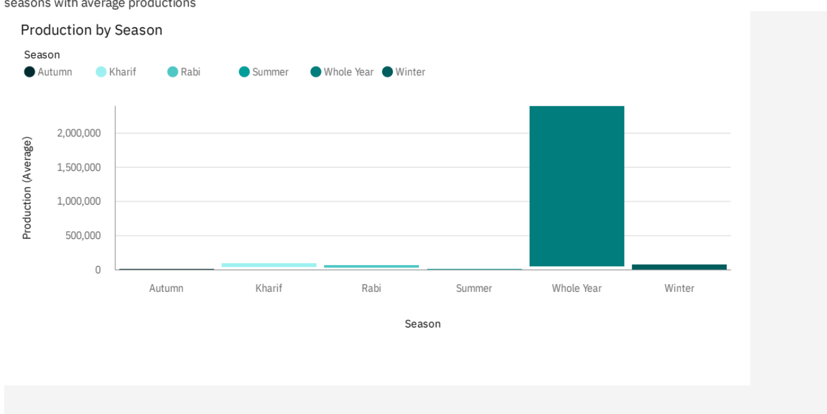

**With Years Usage Of Area And Production**

In our dataset we also have a year’s columns by which we will plot a line and area graphs to see the change in these both data with respect to increase in years. Brief explanation is given in the video provided below.

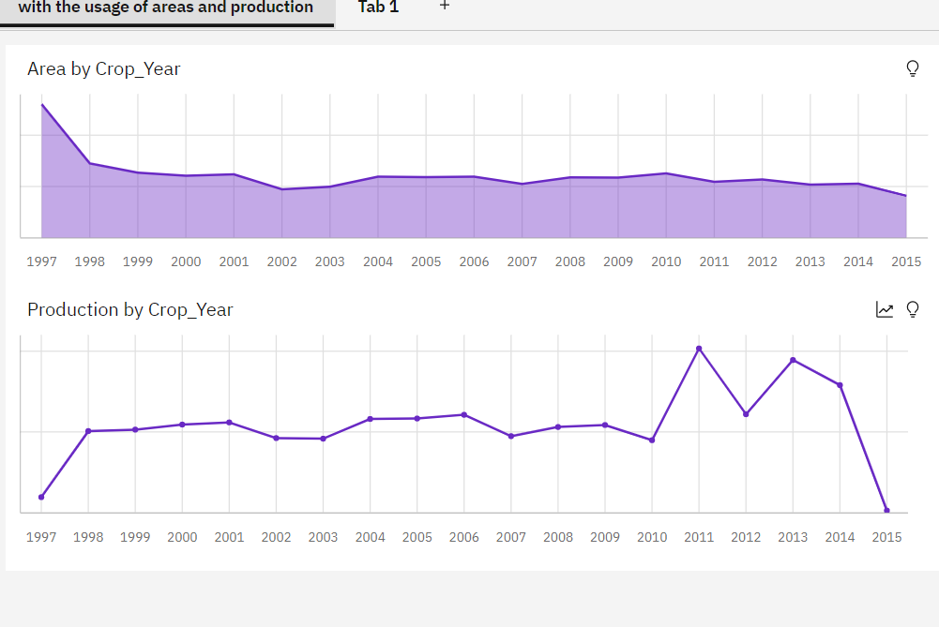

**Top 10 States With Most Area**

As we have an area data in our dataset, we will be plotting some graphs to visualize the top 10 Indian states with the most area as shown in the video.

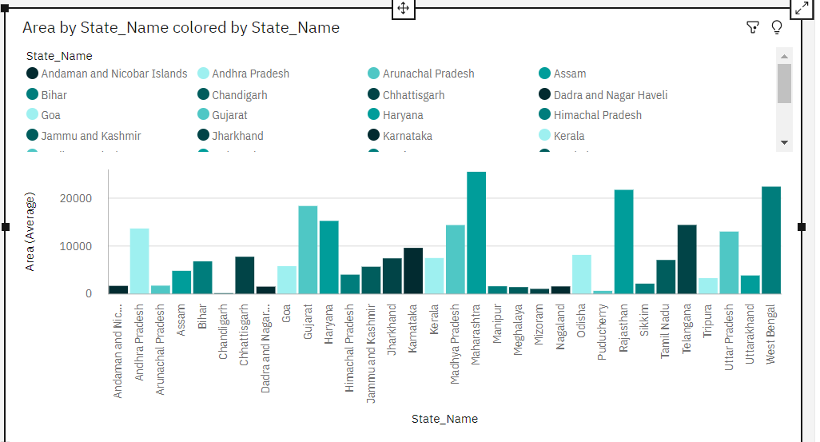

**State With Crop Production**

There are so many different crops produced in Indian and most of us don’t know which crop is belongs to which state so we will be plotting and highlight the states in map according to different crops. Watch the video highlighting the states.

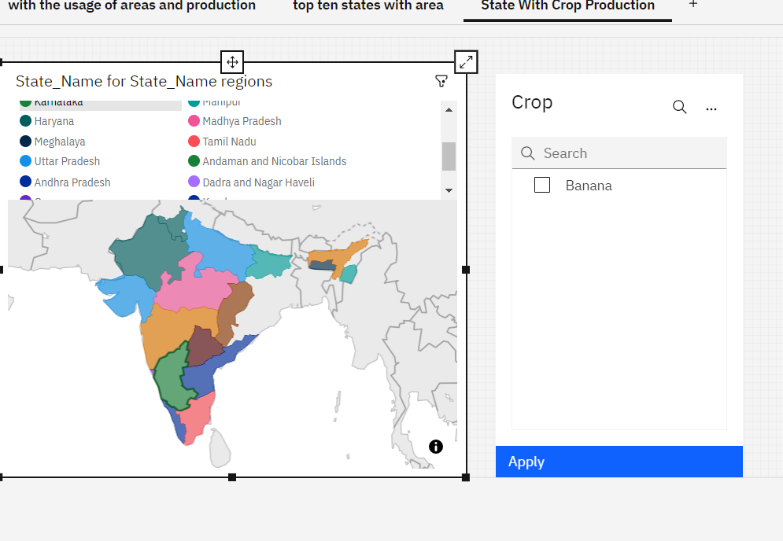

**States With The Crop Production Along With Season (Text Table)**

Taking forward the previous plot we will be fetching the state name and showing it in a text table whenever different crops are chosen. watch the video for brief explanation.

